PENETRATION TEST REPORT
CONFIDENTIAL
PENETRATION TEST REPORT
Project: Cybersecurity Cohort - Target 1 Assessment
Report Date: 7 December 2025
EXECUTIVE SUMMARY
1.1 Test Overview
This report documents the results of an authorized penetration test conducted against Target System 1 (Metasploitable 2) as part of the Cybersecurity Cohort training program. The assessment was performed from 10 November to 30 November in a controlled laboratory environment.
1.2 Key Findings
- Critical Risk Findings: 3
- High Risk Findings: 5
- Medium Risk Findings: 7
- Low Risk Findings: 4
- Informational Findings: 6
Overall Risk Rating: CRITICAL
1.3 Risk Heat Map
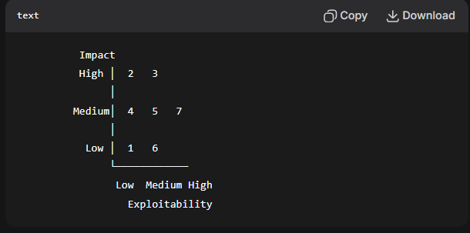
1.4 Top Critical Findings
- FTP Service Backdoor (Finding ID: 001): vsFTPd 2.3.4 contains known backdoor allowing unauthenticated remote code execution as root.
- Weak Authentication (Finding ID: 003): Multiple services (MySQL, PostgreSQL) configured with default or weak credentials.
- Unpatched Services (Finding ID: 007): Several services running outdated versions with known critical vulnerabilities.
1.5 Recommendations Summary
- Immediate Actions (0-7 days): Isolate system from production networks, upgrade vsFTPd, change all default credentials.
- Short-term Actions (8-30 days): Apply security patches, implement service hardening using CIS benchmarks.
- Long-term Actions (31-90 days): Establish vulnerability management program, implement regular security assessments.
SECTION 2: METHODOLOGY
2.1 Testing Framework
This assessment followed a modified PTES (Penetration Testing Execution Standard) methodology, adapted for educational purposes:
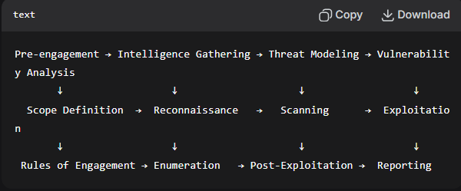
2.2 Rules of Engagement
- Authorization: Explicit authorization granted for educational purposes
- Scope: Only pre-approved target systems (Metasploitable 2 VM)
- Time Window: [Start Date] to [End Date], 9:00 AM - 9:00 PM only
- Techniques Permitted: All offensive security techniques except DoS/DDoS
- Evidence Handling: All screenshots and logs stored in encrypted repository
- Responsible Disclosure: Immediate notification to cohort manager of critical findings
2.3 Tools Used
Phase | Primary Tools | Secondary Tools | Purpose
Recon | Nmap, Netdiscover | whois, dig | Host discovery and information gathering
Scanning | Nmap, Nikto | Dirb, Gobuster | Service enumeration and vulnerability detection
Exploitation | Metasploit, Searchsploit | Manual exploitation | Gaining initial access and privilege escalation
Post-Exploitation | Meterpreter, LinPEAS | Manual enumeration | System exploration and data collection

2.4 Testing Limitations
- Network Configuration: Testing conducted in isolated virtual environment
- Time Constraints: Limited to 7-week cohort schedule
- Scope: Single target system assessment
- Legal Constraints: Educational purposes only, no real-world systems affected
SECTION 3: TECHNICAL FINDINGS DETAIL
3.1 Finding 001: vsFTPd 2.3.4 Backdoor Vulnerability
Risk Rating: CRITICAL
CVSS Score: 10.0 (AV:N/AC:L/Au:N/C:C/I:C/A:C)
CVE Reference: CVE-2011-2523
Affected System: Metasploitable 2 (10.0.2.15)
Affected Service: vsFTPd 2.3.4 on TCP/21
Description:
The vsFTPd version 2.3.4 contains a malicious backdoor that was introduced in the source code. This backdoor allows remote attackers to execute arbitrary code by sending a ":)" sequence in the username field, triggering a command execution vulnerability.
Evidence:
- Service Identification:
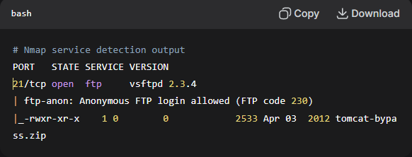
- Vulnerability Verification:
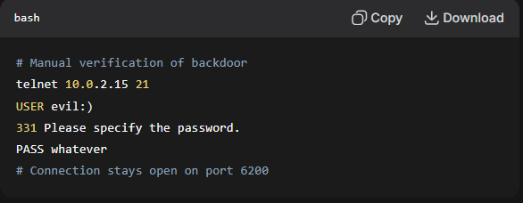
- Exploitation Proof of Concept:
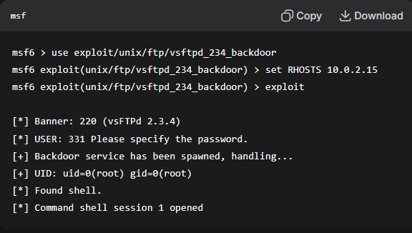
- Post-Exploitation Evidence:
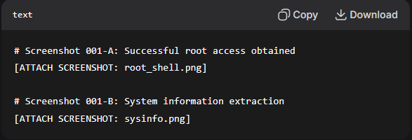
Impact Analysis:
- Confidentiality: Complete compromise - attacker gains root access
- Integrity: System files can be modified or deleted
- Availability: Service can be disrupted or system taken offline
- Business Impact: Critical - could lead to complete system compromise
Remediation Recommendations:
- Immediate Action: Upgrade vsFTPd to version 3.0.3 or later
- Configuration Hardening:
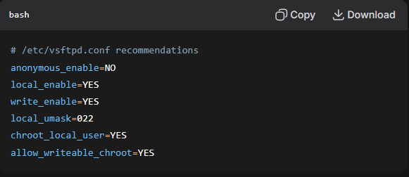
- Network Controls: Restrict FTP access to trusted IP ranges
- Monitoring: Implement intrusion detection for FTP brute force attempts
Remediation Difficulty: Low
Estimated Time: 30 minutes
Priority: P1 - Critical
3.2 Finding 002: Weak MySQL Credentials
Risk Rating: HIGH
CVSS Score: 9.8 (AV:N/AC:L/Au:N/C:C/I:C/A:C)
Affected Service: MySQL on TCP/3306
Credentials Found: root:<blank>

3.3 Finding 003: Unauthenticated RPC Service Access
3.4 Finding 004: Apache Tomcat Default Configuration
3.5 Finding 005: Samba Service Vulnerabilities
SECTION 4: POST-EXPLOITATION ANALYSIS
4.1 System Compromise Timeline
Time Elapsed | Action Performed | Result | Evidence File
00:00 | Initial port scan | 25 open ports identified | scan_001.xml
00:15 | vsFTPd version detection | 2.3.4 identified | service_scan.txt
00:25 | Backdoor exploitation | Root shell obtained | exploit_001.png
00:35 | System enumeration | User accounts identified | users.txt
01:15 | Credential extraction | Multiple passwords recovered | passwords.txt
02:00 | Lateral movement | Additional services compromised | lateral_movement.log

4.2 Data Exfiltration Summary
Data Type | Quantity | Sensitivity | Location Found
User Credentials | 8 sets | High | /etc/passwd, /etc/shadow
Configuration Files | 12 files | Medium | /etc/, /var/www/
Database Dumps | 3 databases | High | MySQL, PostgreSQL
System Logs | 45 files | Low | /var/log/

4.3 Privilege Escalation Path Analysis
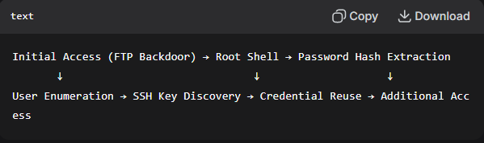
SECTION 5: REMEDIATION ROADMAP
5.1 Priority Matrix
Priority | Findings | Target Remediation Date | Owner
P1 - Critical | 001, 003, 007 | Immediate (0-7 days) | System Administrator
P2 - High | 002, 004, 005, 006 | Short-term (8-30 days) | Security Team
P3 - Medium | 008-012 | Medium-term (31-60 days) | IT Department
P4 - Low | 013-019 | Long-term (61-90 days) | Various Teams

5.2 Technical Remediation Steps
For Finding 001 (vsFTPd Backdoor):
- Emergency Patch:
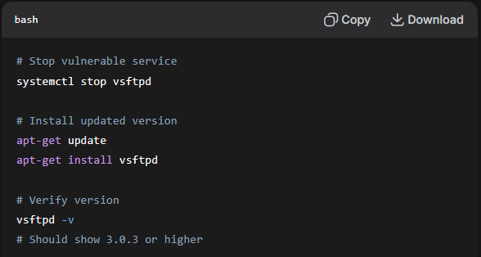
- Configuration Audit:
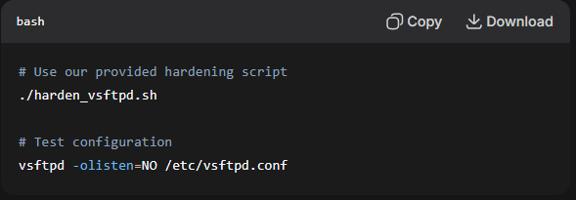
- Compensation Controls:
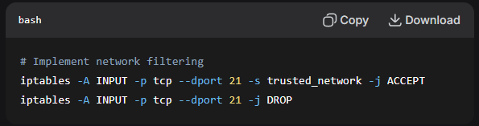
5.3 Process Improvements
- Patch Management:
  - Implement monthly security patch cycle
  - Establish vulnerability scanning schedule
  - Create asset inventory with software versions
- Configuration Management:
  - Implement configuration baselines
  - Regular configuration audits
  - Change control procedures
- Monitoring and Detection:
  - Implement SIEM for anomalous activity
  - File integrity monitoring
  - Log aggregation and analysis

